Objective: Implement Abstraction.

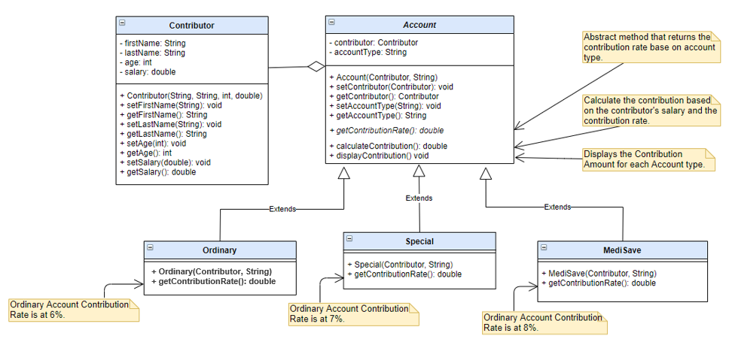

**Sample Output:**

Salary: 10000.00

=== Ordinary Account ===

Contribution Amount: 600.00

=== Special Account ===

Contribution Amount: 700.00

=== MediSave Account ===

Contribution Amount: 800.00

**Instructions:**

1. In your Java project, create a package.
2. Create classes for **Ordinary**, **Special** and **MediSave** based on the UML Class diagram.
3. Provide implementation to ***getContributionRate()*** method for each class based on the contribution rate specified in the diagram.
4. Create **ContributorMain** class which will contain the **main()** method and will perform the following:
   * Create Contributor object.
   * Display salary.
   * Create Ordinary Account object.

Display contribution.

* + Create Special Account object.

Display contribution.

* + Create MediSave Account object.

Display contribution.